# Models (2 choices):

## 2 perpendicular Motors (with a base pole in the center):

Simpler (one motor to control orientation X and one for Y) (+)

Requires less Equipment -> Cheaper (+)

## 3 Motors 360/3 (without a base pole in the center):

More complex (any combination of 3 angles will give a certain inclination) (-)

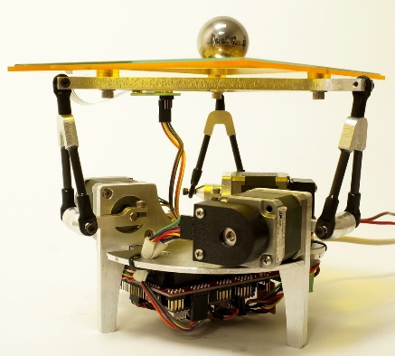More Equipment -> More expensive (-)

Robust (+)

More of a Challenge (harder modelling and Control) (-)

# Requirements:

## Motors:

* Servo:

Easier to control (+)

Already comes with an encoder (+)

Much better for dynamic behavior (++)

Constant Torque to speed change (+)

Less power consumption (+)

* Stepper:

Harder to control (needs a drive) (-)

Needs an encoder for feedback (-)

Very accurate (++)

Higher power consumption (-)

## Position Sensor:

* Camera:

Requires a backend for image processing (--)

Can detect ball even if not on plate (predictive behavior) (++)

Adaptable for any kind of base shape (+)

Needs an Aditional Structure to hold the Camera (-)

* Resistive Touch screen:

Can only detect ball if ball Is on the base (no predictive behavior) (-)

Easy measurements (position X and Y) (++)

Limited to Base shape and Dimension (-)

No need for backend (++)

Noisy (---)

Requires a certain pressure to give readings (---)

## Control PCB:

* Arduino or Any Commercial Board:

Needs a Servo Shield module to power up the servos (-)

Commercially Available and Cheap (++)

Easy to Program and implement (+)

* Custom Made Board:

Needs time to Design and Build (--)

Needs Experience in Electronics and PCB design software (-)

Complicated and Hard to Program (-)

Customized for our Need 🡪 efficient and optimal (+)